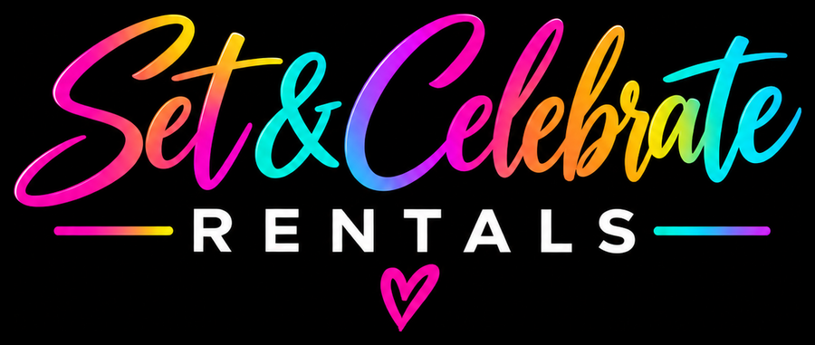
Set & Celebrate Rentals
Liability Waiver & Release of Claims
Please read every section carefully. This waiver must be signed before your booking is confirmed.
SECTION 1
Assumption of Risk
The Client acknowledges and agrees that the use of rental equipment provided by Set & Celebrate Rentals — including but not limited to inflatables (the bounce house with wet or dry slide and the 10ft inflatable soccer dart board), chairs, tables, linens, lawn games (Corn Hole, Giant Connect Four, Giant Jenga), Nerf battle equipment, centerpieces, decorations, and any other items rented — carries inherent risks of injury, accident, or property damage. These risks include, but are not limited to:
- Falls, collisions, sprains, or broken bones while jumping, climbing, or sliding on inflatables
- Slips and falls on wet, slippery surfaces when the slide is used wet (with water)
- Trips, slips, or falls involving chairs, tables, or other furniture
- Injuries resulting from the use of lawn games or Nerf battle equipment
- Injuries to participants of any age, including children, during Nerf battles or game play
- Injuries resulting from improper use, horseplay, or misuse of any rented item
- Property damage to the event venue or surrounding area caused by rented equipment
- Injuries caused by third parties (guests, children, bystanders) interacting with rental items
⚠ Nerf & Lawn Games Notice: Adult supervision is strongly recommended at all times, especially when children are participating. Safety goggles are provided and must be worn during Nerf activities.
SECTION 2
Release & Waiver of Liability
In consideration of being permitted to rent equipment from Set & Celebrate Rentals, the Client, on behalf of themselves and all guests, participants, and invitees attending the event, hereby releases, waives, discharges, and covenants not to sue Set & Celebrate Rentals, its owner(s), employees, agents, representatives, and affiliates ("Released Parties") from any and all liability, claims, demands, actions, or causes of action arising out of or related to any loss, damage, or injury — including death — that may be sustained by the Client or any guest, whether caused by the negligence of the Released Parties or otherwise.
⚠ Set & Celebrate Rentals is NOT responsible for any personal injury, bodily harm, accident, or death that occurs to the Client, their guests, children, or any third party during the use of any rented equipment.
SECTION 3
Client Responsibilities & Supervision
The Client agrees to:
- Ensure all rented equipment is used safely, appropriately, and lawfully
- Provide adequate adult supervision at all times, especially when children are present
- Instruct all guests on the proper and safe use of all rented items before use
- Stop use of any damaged or unsafe item immediately and notify Set & Celebrate Rentals
- Ensure Nerf goggles are worn by all participants during Nerf activities
- Keep rented equipment away from pools, open flames, steep terrain, or hazardous conditions
- Not allow individuals under the influence of alcohol or drugs to use equipment
- Accept sole responsibility for the actions of all guests and participants
SECTION 4
Inflatables — Bounce House with Wet or Dry Slide
The bounce house with slide can be rented dry or wet (with water). The Client understands that a wet slide is slippery and carries added risk of slips, falls, and collisions, and accepts these risks whichever option is chosen. When using any inflatable, the Client agrees to:
- Have a responsible adult watching the inflatable at all times while it is in use
- Keep the number of riders within safe limits and group riders of similar age and size together
- Allow no shoes, glasses, jewelry, sharp objects, food, drinks, gum, or silly string on the inflatable
- Allow no flips, wrestling, rough play, climbing on the walls, or hanging from the netting
- Slide feet first or seated only, one rider at a time, and keep the landing area clear
- For wet use: keep the area around the slide free of hazards, allow only clean water through the hose, and keep electrical cords and the blower away from water
- Keep the blower running at all times, never move, unplug, or re-stake the inflatable, and clear everyone off at once if it starts to deflate
- Stop use and clear the inflatable immediately in high winds, rain, or lightning
⚠ Wet or Dry Slide Notice: Set & Celebrate Rentals is not responsible for any injury that occurs on or around the bounce house or slide, whether it is used wet or dry. The Client is responsible for any damage to the lawn, venue, or property from water use.
SECTION 5
Indemnification
The Client agrees to indemnify, defend, and hold harmless Set & Celebrate Rentals and its Released Parties from and against any and all claims, suits, losses, damages, costs, and expenses (including attorney fees) arising from: any personal injury or death caused by use of rented equipment; any negligent or wrongful act by the Client or their guests; any misuse of rented equipment by any person at the event; or any violation of this Waiver.
SECTION 6
Equipment Condition & Damage Policy
The Client agrees to inspect equipment upon delivery, report pre-existing damage immediately, and return all items in the same condition received. The Client agrees to: pay a $100 fully refundable damage deposit on any booking that includes an inflatable; accept a $40 flat replacement fee per damaged/lost decoration, lawn game, or centerpiece; and pay any replacement costs exceeding the $100 deposit for higher-value items upon invoice.
SECTION 7
Weather & Outdoor Use
The Client acknowledges risks associated with outdoor use and agrees to secure equipment immediately if severe weather or unsafe conditions arise. Set & Celebrate Rentals is not responsible for injury or damage resulting from weather conditions or the Client's failure to take precautionary measures.
SECTION 8
Governing Law
This Waiver shall be governed by the laws of the State of Texas. Any disputes shall be subject to the jurisdiction of the courts in Harris County, Texas. If any provision is found invalid, remaining provisions continue in full force.
SECTION 9
Acknowledgment of Understanding
The Client certifies that they: are 18 years of age or older; have read this Waiver in its entirety; are signing freely and voluntarily; understand this is a legally binding document; and agree that this Waiver covers all guests and participants at their event.
By signing below, you agree that Set & Celebrate Rentals, its owner, and representatives shall NOT be held liable for any personal injury, accident, bodily harm, or death that occurs to you, your guests, or any third party during the rental period or at your event.

Client Agreement
I, the undersigned, have read the entire Liability Waiver & Release of Claims, understand its contents, and agree to be bound by its terms. I acknowledge that Set & Celebrate Rentals is not responsible for any injuries, accidents, or damages that may occur during the rental period, and I accept full responsibility for the safe use of all rented equipment by myself and all guests at my event.
Client Full Name (print):  ______________________________________ | Event Date:  ______________________________________
Client Signature:  ______________________________________ | Date Signed:  ______________________________________
Phone:  ______________________________________ | Email:  ______________________________________
Event Address:  ______________________________________ | Bounce House Slide: ☐ Dry ☐ Wet

Notes (who is supervising, guests signing on site, medical notes, etc.):
______________________________________________________________________________________
______________________________________________________________________________________
______________________________________________________________________________________

Please sign and return this waiver by email or bring it to your event. A copy is kept with your booking.

